Exp No : 2
Date : 08/02/2019
Aim : To understand Linux commands for operations such as redirection, pipes, filters, job control, changing ownership/permissions of files/links/directory.

Command 1 : redirect
Purpose of command : redirect the output of a command from screen to a file.
Usage : command > “filename.txt” #write to the file
command >> “filename.txt” #append to the file
Sample input and output
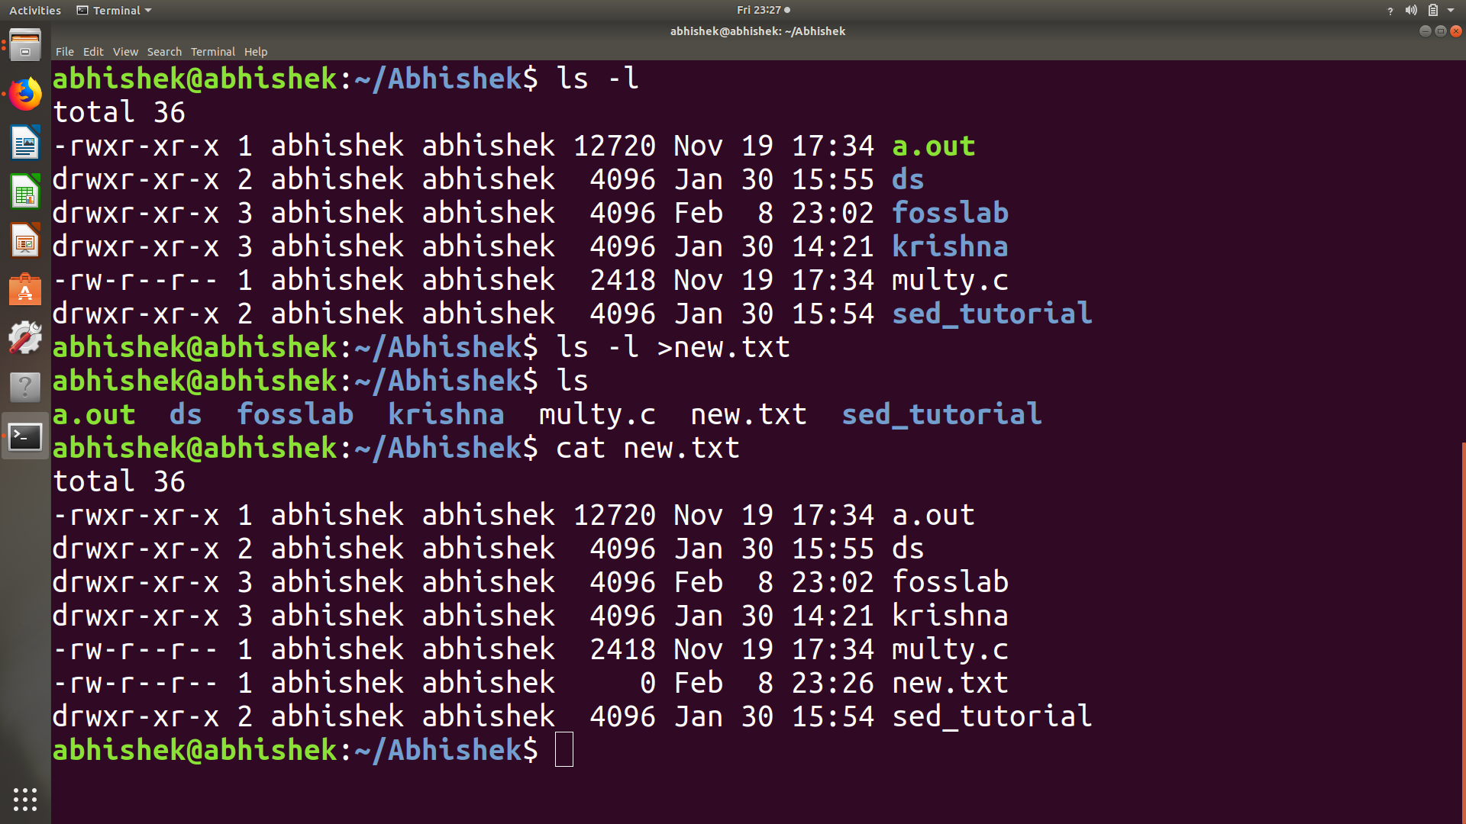
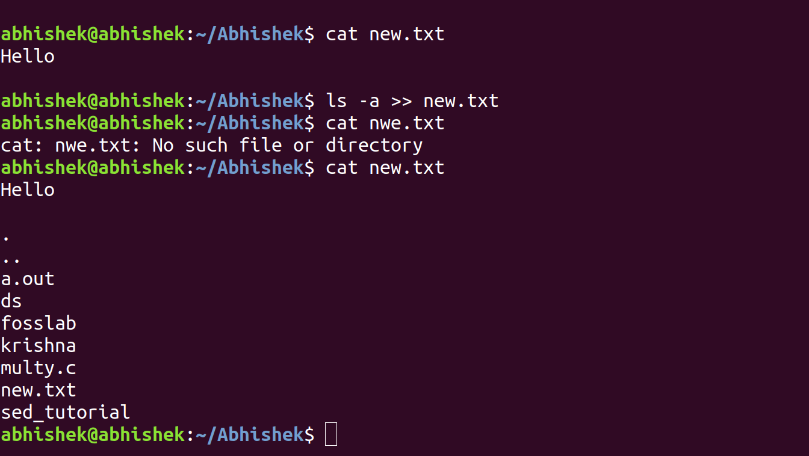

Command 2 : pipes
Purpose of command : The Pipe is a command in Linux that lets you use two or more commands such that output of one command serves as input to the next.
Usage : command 1 | command 2
Sample input and output
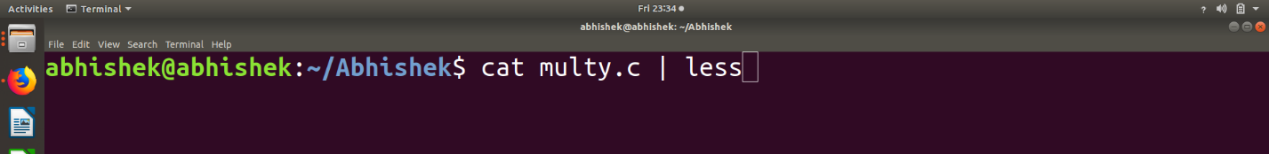
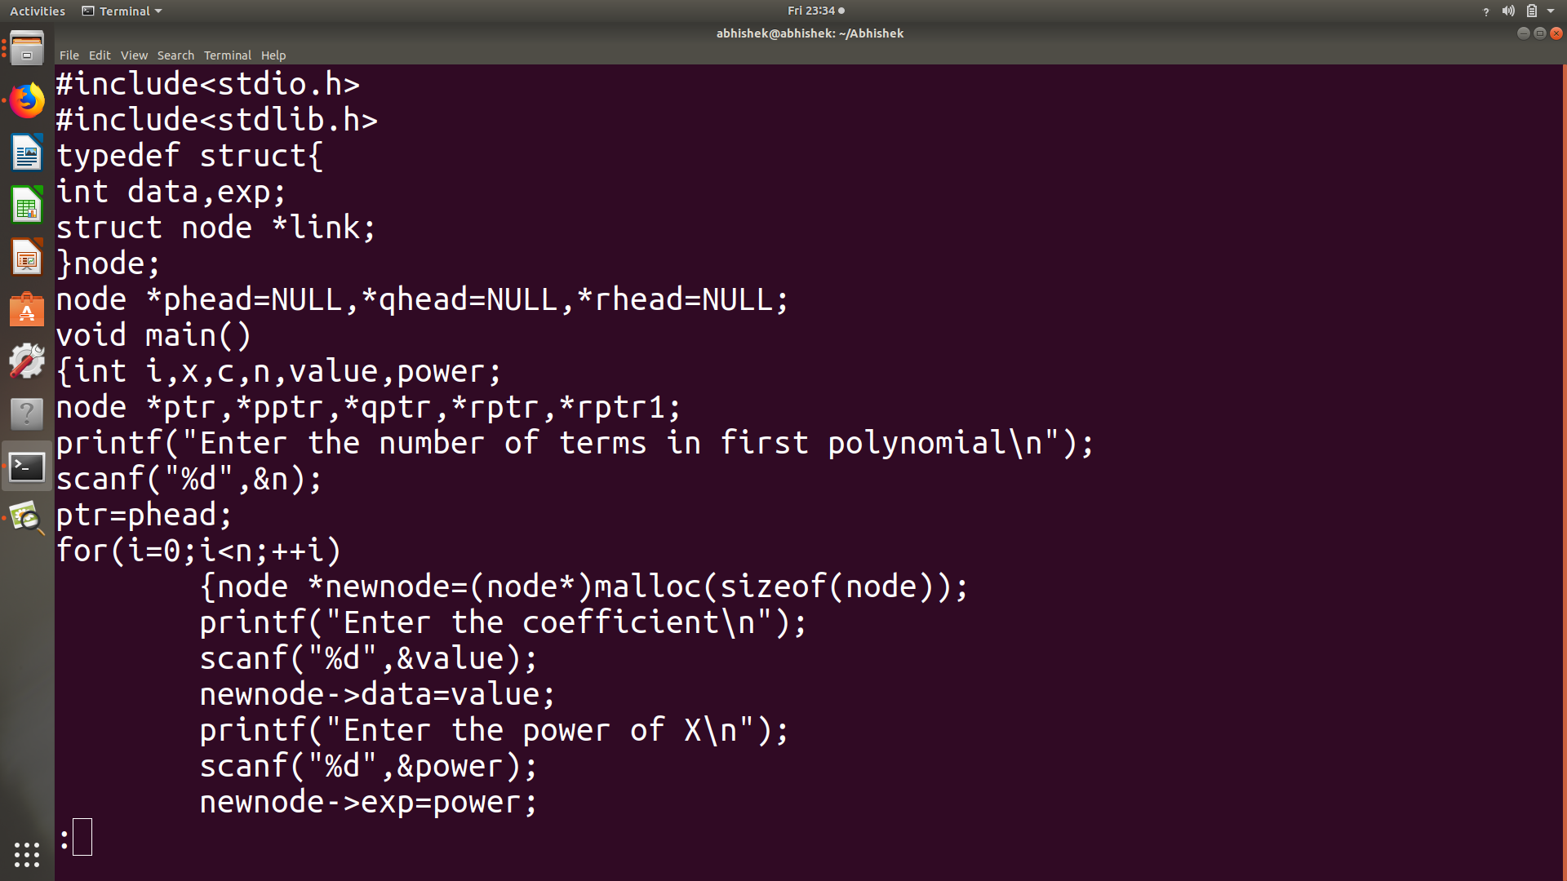
Command 3: filters
Purpose of command : A filter is a program that reads standard input, performs an operation upon it and writes the results to standard output.
Usage : head -n “filename” #show first n lines of a text.
tail -n “file name” #show last n lines of a text.
grep “substring” filename #shows matching pattern. etc
Sample input and output:
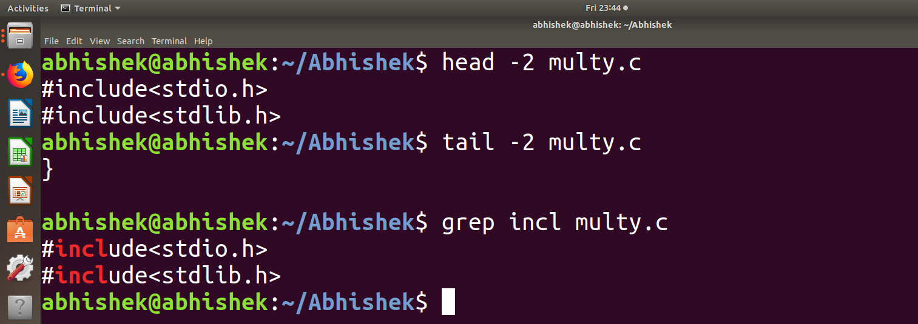

Command 4: chmod
Purpose of command : changing permission
Usage : chmod 777 “filename” #provide all permission
chmode + or - (x,r,w) filename #add or remove permission
Sample input and output
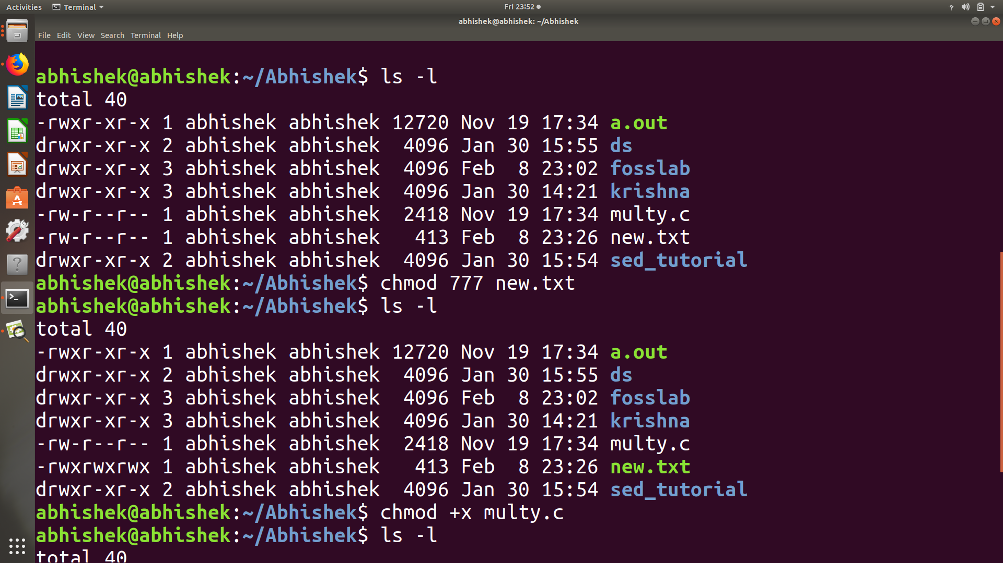
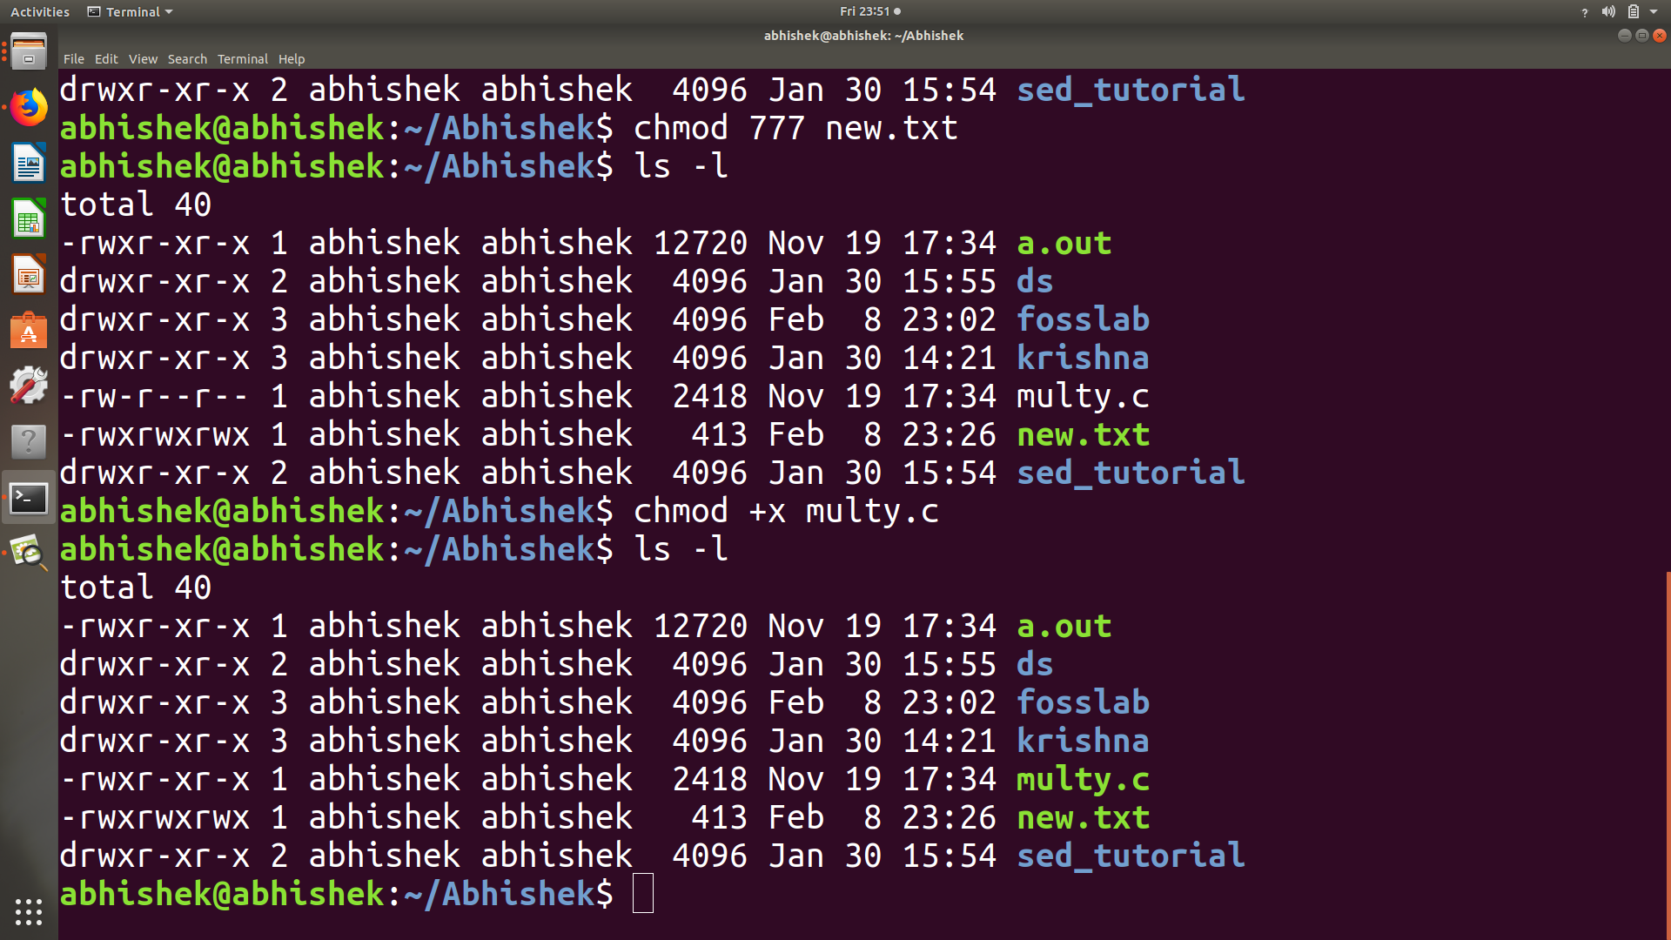

Command 4: jobs
Purpose of command : To do job control options
Usage : jobs j #to list all the jobs that are running or suspended.
fg %job number#Bring the job to the foreground.
bg %job number#Send the job to the background.
Stop %job number# Suspend the job.
Kill %job number# Terminate the job.
Sample input and output

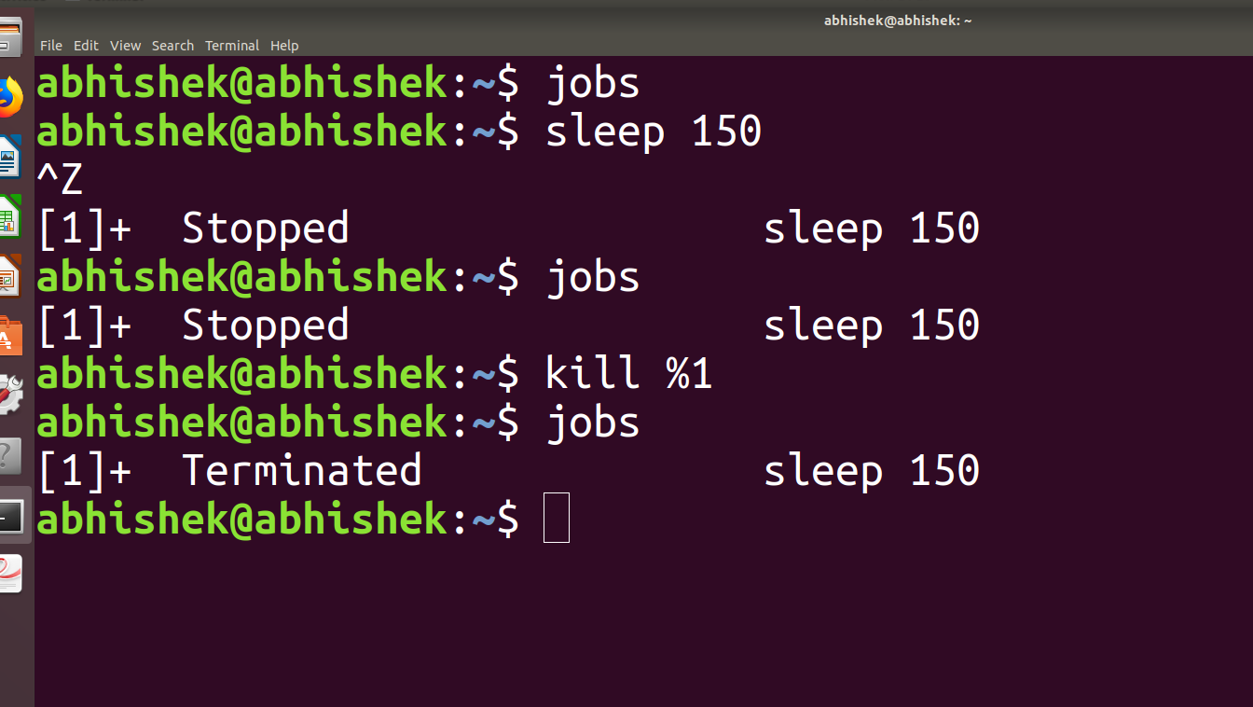

Aim : Getting started with Advanced linux commands curl, wget, ftp, ssh and grep.

Command 5: curl

Purpose of command : It is a command line tool for receiving and sending files using URL syntax.

Usage: curl “web address” #To see the content of a web address.

Sample input and output
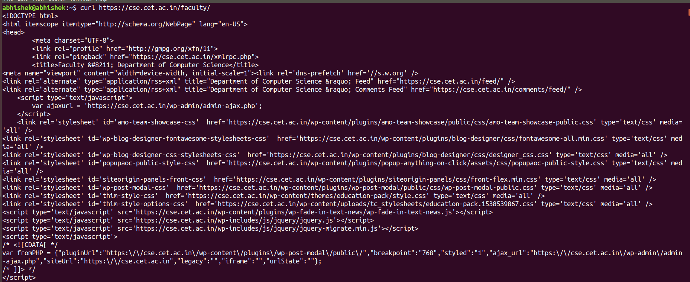
Usage: curl -o “web address” “filename” #To save the output to the file
sample input and output:

Command 6: wget

Purpose of command : To download a web page.

Usage: wget “web address” #To see the content of a web address.
wget -b “webaddress” #To download the file in background

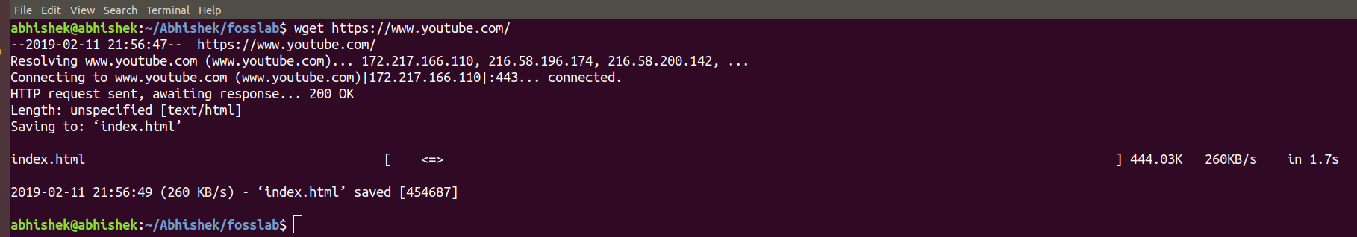
Sample input and output

Command 7: ftp

Purpose of command : To open an ftp connection to a remote system use the ftp command followed by the remote server IP address or domain name:

Usage: ftp “ IP”
cd - change directory on the remote machine.
lcd - change directory on the local machine.
ls - list the names of the files and directories in the current remote directory.
mkdir - create a new directory within the current remote directory.
pwd - print the current working directory on the remote machine.
delete - remove a file in the current remote directory.

